Comal Cops for Kids Foundation, Inc.

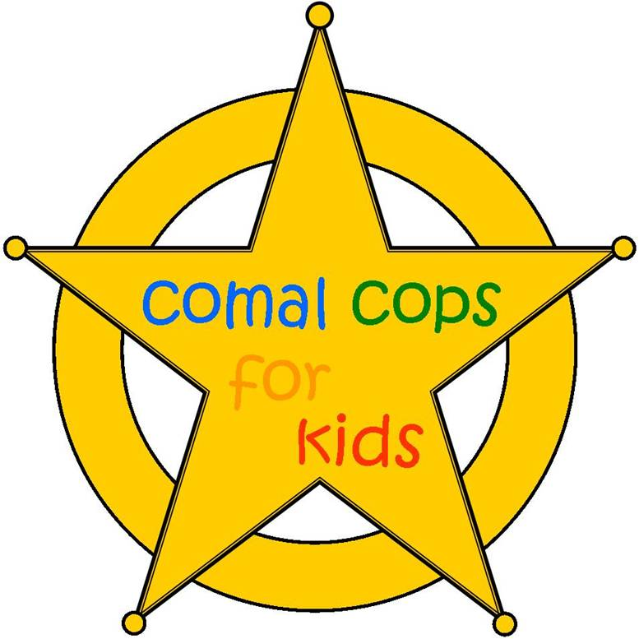

Turkey Trot Sponsorship Packet
Promote your business. Give back to the community.

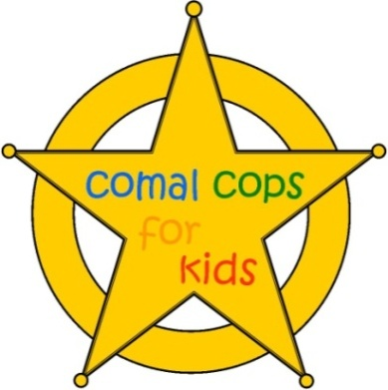

P.O. Box 312143 New Braunfels, TX 78131-2143

Dear Prospective Sponsor,

Comal Cops for Kids Foundation, Inc. invites you to be a sponsor for the Annual Comal Cops for Kids Gruene Turkey Trot. The Turkey Trot includes a 5K walk/run for adults and a Kids’ ¼ Mile Turkey Chase and will be held in Gruene, Texas on Thanksgiving Day. All proceeds of the race will benefit and assist in funding local charitable and non-profit organizations, which support law enforcement efforts in Comal County to benefit the children of our community.

We invite you to take advantage of this exceptional advertising and promotional opportunity as a sponsorship participant. Advertise your business through T-shirts, banners, brochures, and much more. We have provided details of all your sponsorship benefits in this packet and hope you join us in supporting the organizations that facilitate the ability of law enforcement to better serve our children, including the New Braunfels Police Department Blue Santa Program, Comal County Sheriff’s Office Green Santa Program, Comal County Sheriff’s Office D.A.R.E., Junior Deputy Academy, and many other agencies.

Please submit the enclosed Sponsorship Letter of Agreements and any artwork by their respective due dates to be included in promotional materials. If you have any questions or would like more information, please contact Tommy Ward at (210)317-4939.

Sincerely,
Tommy Ward
President

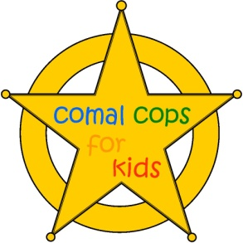
Our Foundation Mission:
We are a non-profit 501(c)(3) foundation dedicated to benefiting abused, endangered, or underprivileged children by financially supporting non-profit organizations and government agencies that assist local law enforcement agencies in protecting the children of Comal County.

Why the Foundation was Created:
In the summer of 2009, Detective Sergeant Tommy Ward and Deputy Mykel Andaloro from the Comal County Sheriff’s Office teamed with three prosecutors, Jennifer Tharp, Shannon Francis, and Tiffany Colunga, from the Comal County Criminal District Attorney’s Office and founded Comal Cops for Kids Foundation, Inc.

Numerous local non-profit organizations and government agencies work to assist law enforcement and the District Attorney’s Office in protecting our children and prosecuting those who commit crimes against children. The founders of Comal Cops for Kids shared a common goal of wanting to give back to these organizations who are so tirelessly dedicated to the children of our community. Thus, the Foundation was created.

The first fundraising event that the Foundation developed was the Gruene Turkey Trot, a 5K run/walk and kids’ ¼ mile turkey chase, held on Thanksgiving Day each year. This event is the primary winter fundraising event for Comal Cops for Kids Foundation. The inaugural Turkey Trot in 2009 had approximately 700 participants. In 2016 the Turkey Trot has seen a dramatic increase in participants and money raised. In just 8 short years, CCFK has awarded over $331,000 in grants to local non-profit organizations that serve the children of Comal County.

Facts about Comal Cops for Kids:

- Comal Cops for Kids has given over $331,000 to local charities that help law enforcement better serve the children of Comal County.
- Comal Cops for Kids Foundation, Inc.’s Board of Directors is comprised of individuals from the Comal County Sheriff’s Office, Comal County District Attorney’s Office, New Braunfels Police Department, and Garden Ridge Police Department.
- Turkey Trot has seen over 10,000 participants and has raised over $331,000. There has been a steady increase in participants and money raised each year.
- 2009 – The Turkey Trot had over 700 participants; raised over $20,000 in donations for local non-profit agencies
- 2016 – The Turkey Trot had over 2000 participants; raised over $45,000 in donations for local non-profit agencies.
- The Turkey Trot is an official Gruene Holiday Event
- Medals are awarded to winners of the 5K and every child receives a “Turkey Tommy” medal in the ¼ Mile Turkey Chase
- Law Enforcement personnel are distinguished by wearing black Comal Cops for Kids t-shirts at the race

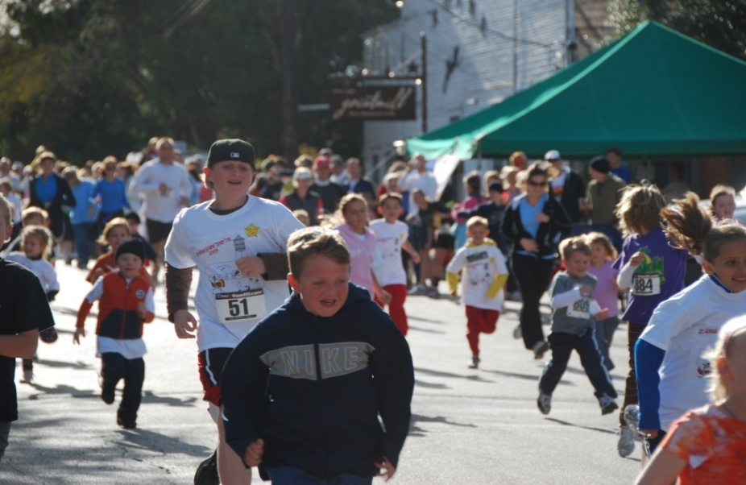
Kids’ ¼ Mile Turkey Chase

Total Grants by Agency
Children's Advocacy Center of Comal County | $56,000.00
CCSO Green Santa Program | $47,000.00
NBPD Blue Santa Program | $48,000.00
Communities In Schools | $23,000.00
SART Foundation | $7,500.00
CCSO Junior Deputy Program | $15,500.00
St. Jude's Ranch for Children | $15,000.00
NB Citizens Police Academy | $10,000.00
Connections | $14,500.00
Lutheran Social Services of the South, Inc. | $10,250.00
CCSO DARE Program | $10,500.00
CASA of Central Texas, Inc. | $17,000.00
CCSO Crime Prevention Program | $7,000.00
Comal County Child Welfare Board | $17,000.00
Big Brothers Big Sisters of Comal County | $18,000.00
New Braunfels Christian Ministries | $14,250.00
Garden Ridge Police Explorers | $9,000.00
 | $331,900.00
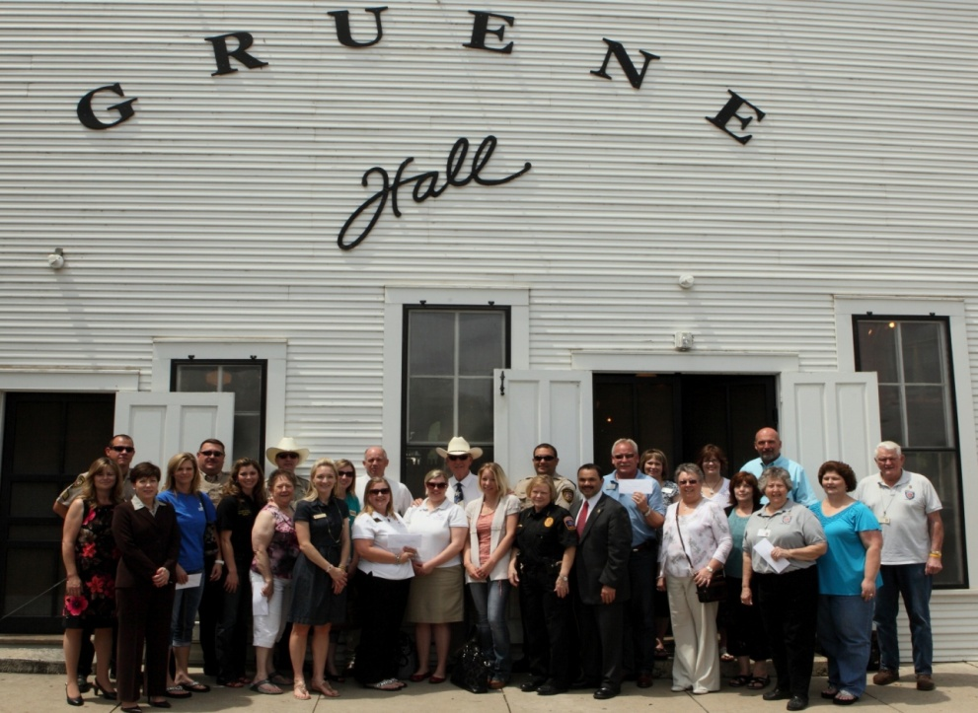

Check Distribution Ceremony at Gruene Hall, April 27, 2012
Why should you become a Sponsor?

- Increase your business’ visibility by supporting a successful event that is anticipated to attract even more runners this year.

- Reach a diverse cross-section of families, teens, college students, and local community members.

- Publicize to thousands of people via advertisements on event shirts, banners, website and social media. Examples below:
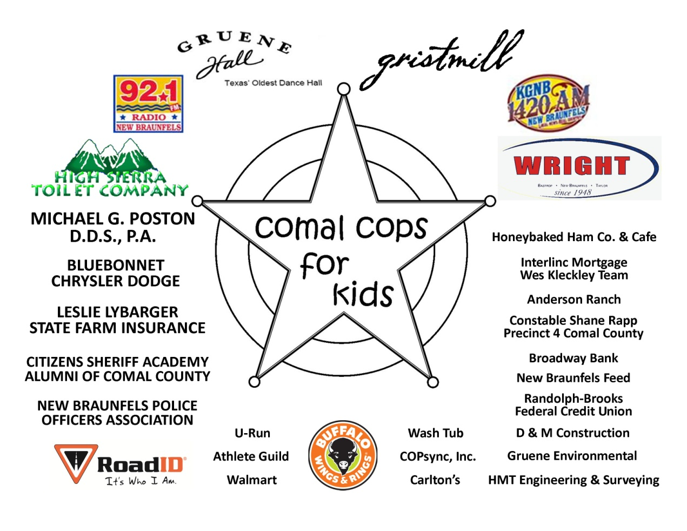

Sponsor Benefits | Chief Sponsor  $5,000 | Captain Sponsor  $2,500 | Lieutenant Sponsor  $1,500 | Sergeant Sponsor  $750 | Officer Sponsor  $500
 | *offers the highest degree of promotional exposure | *featured just below the Chief level in descending size and order | * descends in size & order from previous level & offers an outstanding midlevel value | *descends in size and order from previous level & offers excellent lower level value | *offers event day exposure
Runners/Walkers | 4 entries for run 4 entries for chase | 3 entries for run 3 entries for chase | 2 entries for run 2 entries for chase | 1 entry for run
Website  Your Logo on Cops for Kids website. | Featured Logo  (LARGE) with link to your website | Large Logo | Small Logo | Name Only | Name Only
Social Media  We will feature your business on our Facebook page. | Featured Logo  (LARGE) | Large Logo | Small Logo | Name only | Name only
Event Banner/Boards | Featured Logo  (LARGE) | Large Logo | Small Logo | Name only | Name only
Event day T-shirt | Featured Logo  (LARGE) | Large Logo | Small Logo | Name only | Name only

Annual Turkey Trot Sponsorship Opportunities

SPONSORSHIP LETTER OF AGREEMENT – TURKEY TROT
___________________________________ (“Company”) agrees to provide financial sponsorship for the Annual Gruene Turkey Trot on Thanksgiving Day. As a sponsor, Company understands that it will receive the applicable sponsorship opportunities described in this packet attached hereto and incorporated herein by reference. Company further understands that these opportunities will not be valid until this agreement is signed and Company’s check has been issued to and accepted by the Comal Cops for Kids Foundation, Inc. (“Comal Cops for Kids”). As a sponsor, Company agrees to provide digital artwork (“Logo”) for all promotional advertising. Company understands that if the Logo is not provided to Comal Cops for Kids by October 25th, that the Logo may not be featured in certain promotional materials due to time constraints for printing said materials.

Please check the appropriate level of sponsorship:
________ Chief Sponsor: $5,000 (or in-kind equivalent)
________ Captain Sponsor: $2,500 (or in-kind equivalent)
________ Lieutenant Sponsor: $1,500 (or in-kind equivalent)
________ Sergeant Sponsor: $750 (or in-kind equivalent)
________ Officer Sponsor: $500 (or in-kind equivalent)
________ We are unable to sponsor, but we wish to make a donation. Enclosed is a gift of:
[ ] $50 [ ] $100 [ ] Other: __________

Sponsor Name

Address City State Zip

Representative Name Email Phone Fax

Authorized Sponsor Signature

Please send this completed agreement with check made payable to:
Comal Cops for Kids Foundation, Inc.
P.O. Box 312143
New Braunfels, TX 78131-2143

Comal Cops for Kids Foundation, Inc. gratefully thanks you for your support!

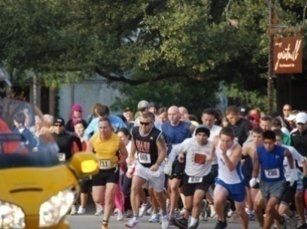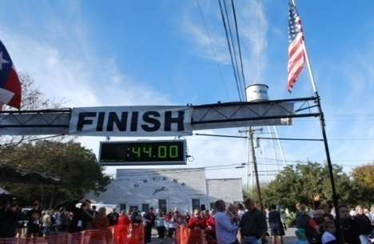
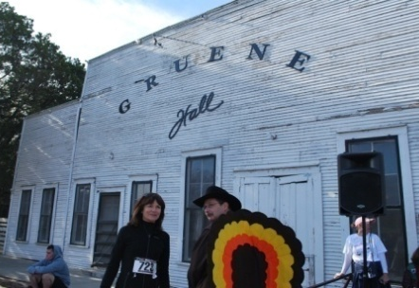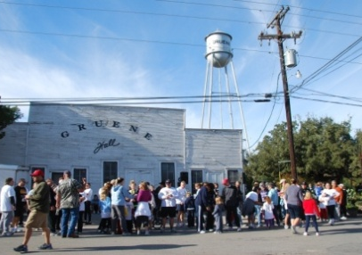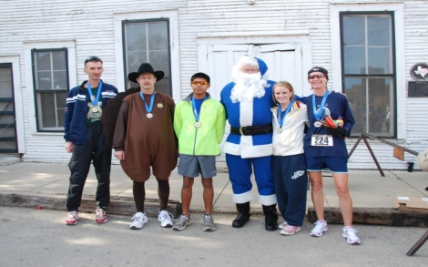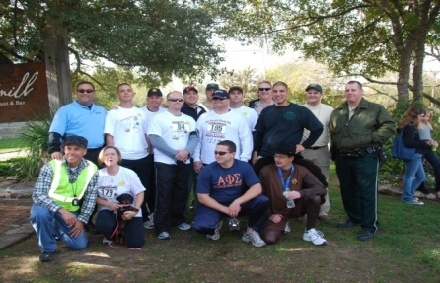
Photographs from 2009 Gruene Turkey Trot

Visit www.comalcopsforkids.org for more information.

